Salesforce Marketing cloud(File Transfer): It pushes Audience from AEP to SFMC FTP location. It will export segment at schedule basis in FTP location. SFMC will pick up the file and imports it into data extension. SFMC journey builder can then use this Automation to trigger a journey.

Details:
Batch Based Integration: Data Can be moved between AEP and SFMC using SFTP file transfer
Typically used when large audiences needs to be ingested
Works with schedule export rather than real time

End To End Flow:
- Data Ingestion : Customer profile data is ingested into AEP
- Create Audience: Build Audience segment
- AEP exports the segment: AEP exports the segment in CSV format
- File pickup(SFMC Side): Import Activity loads data into a Data Extension
- Journey Activation: A journey is configured to use this Automation/DE as an entry source

SFMC Pre-requisite Steps:
Set up a FTP user in SFMC:
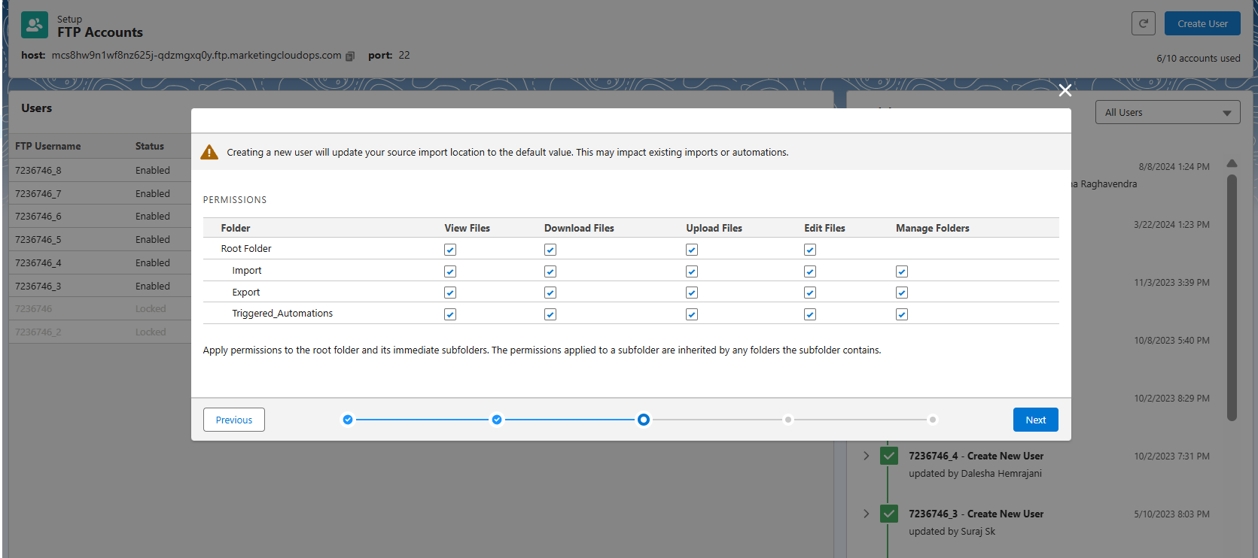
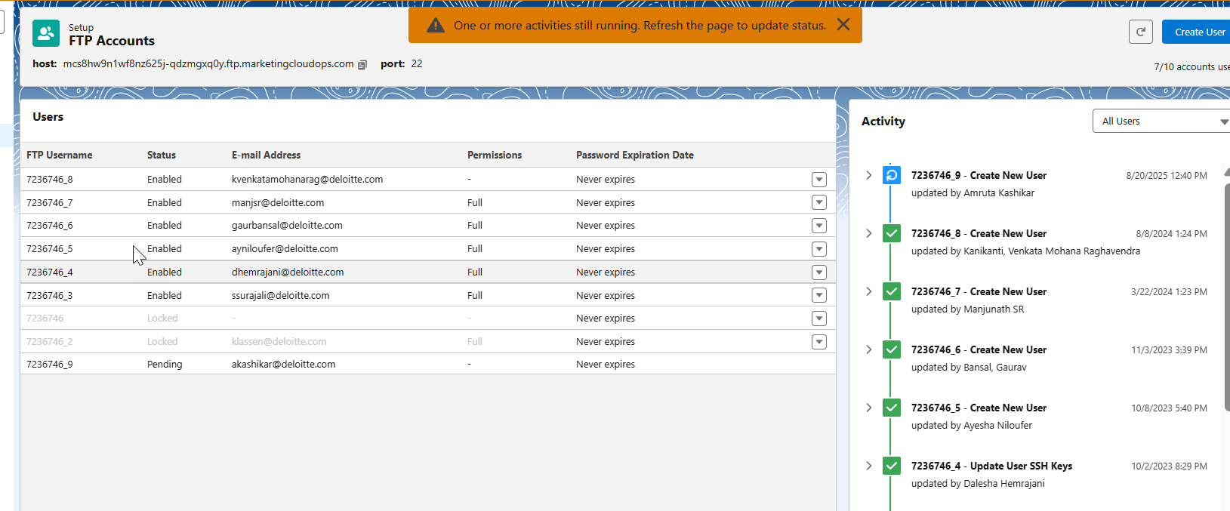

Create a File Location
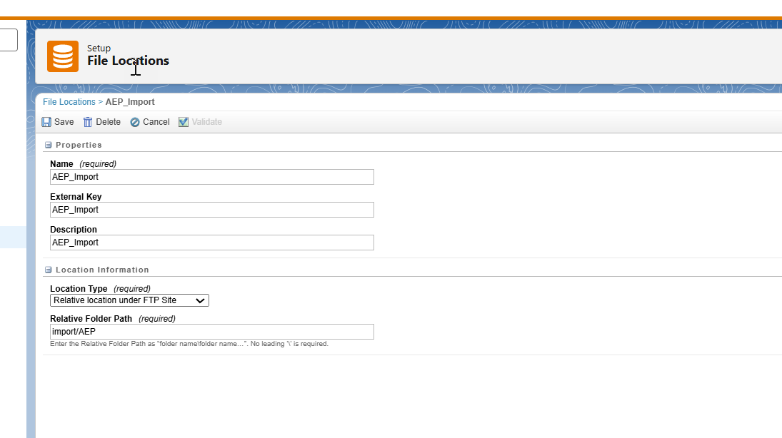

AEP Steps:
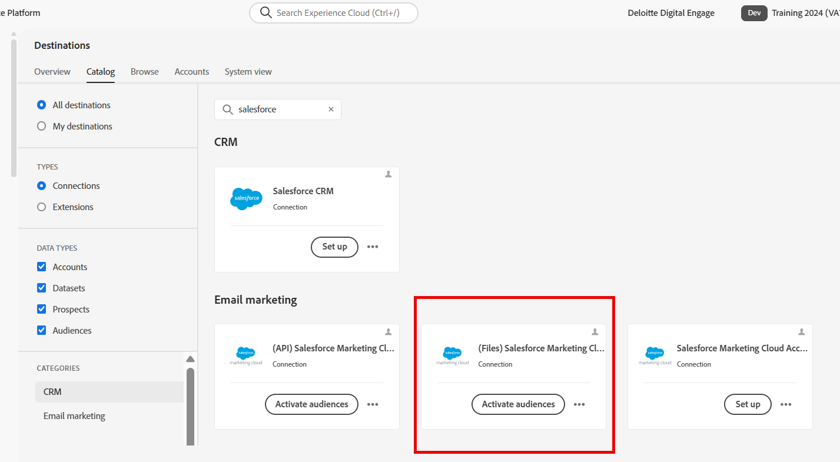

Enter Authentication Details ( These can be obtained from SFMC when setting up a FTP User)
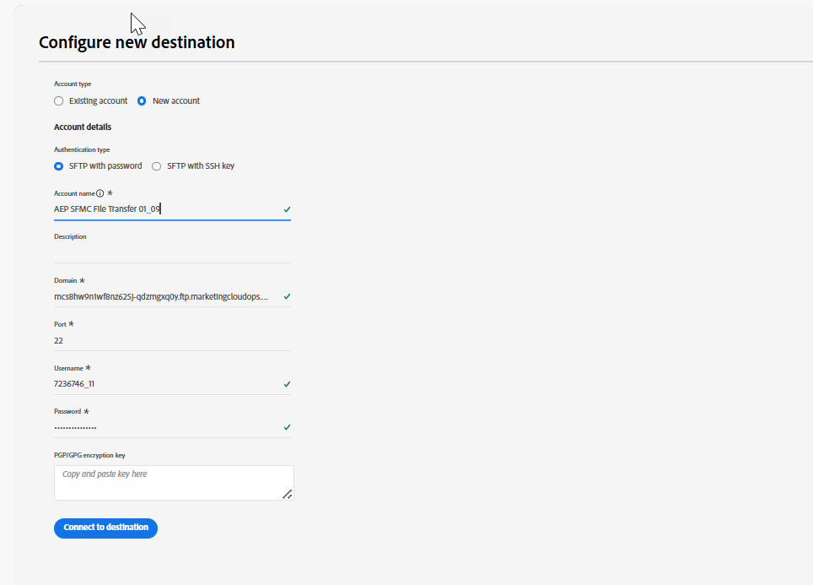

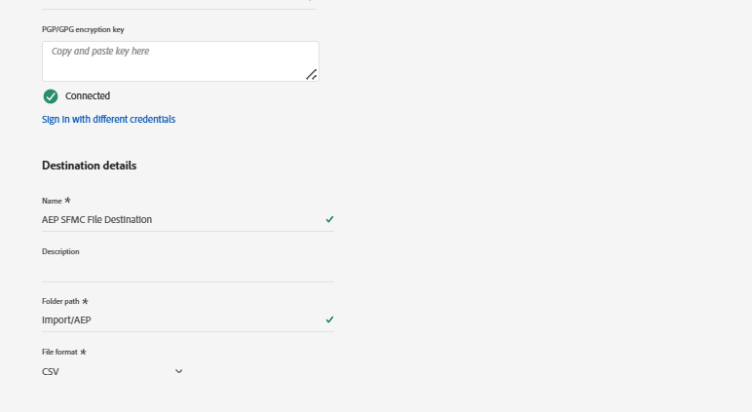

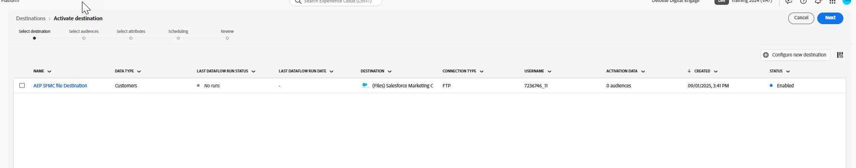

Select Audience to be Activated

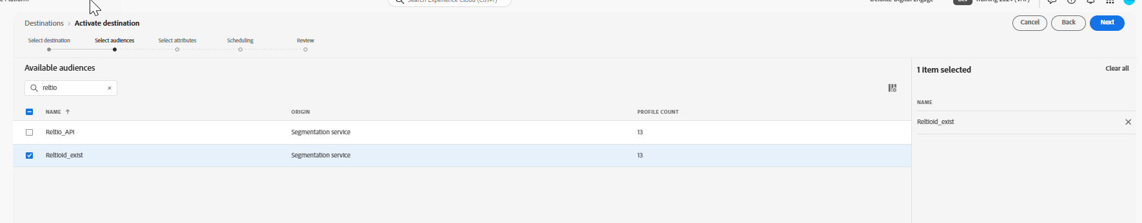

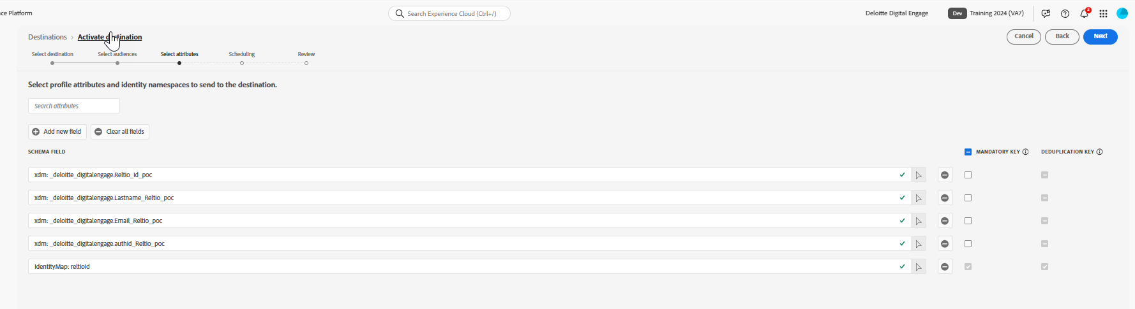

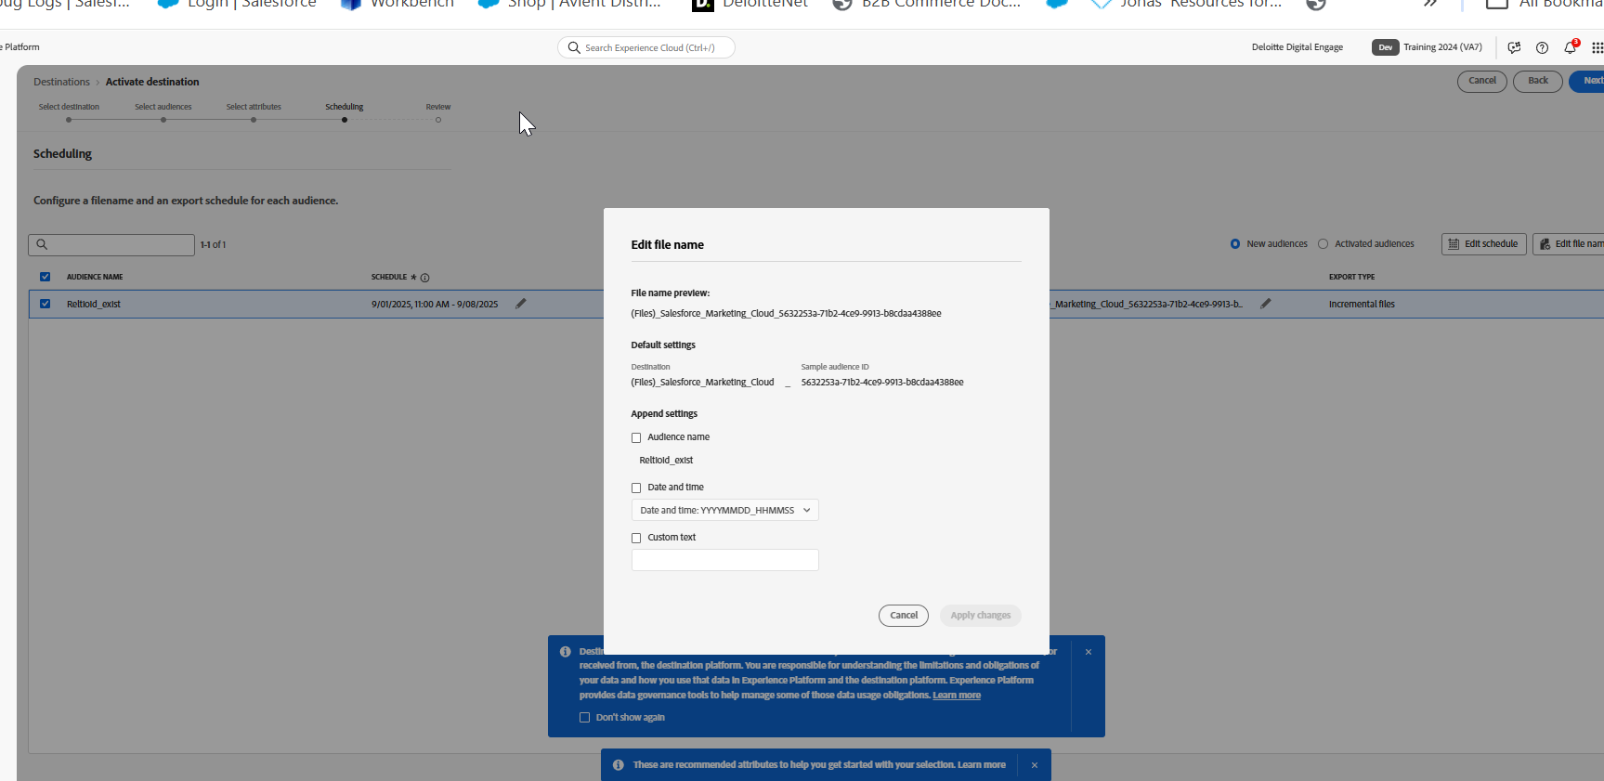

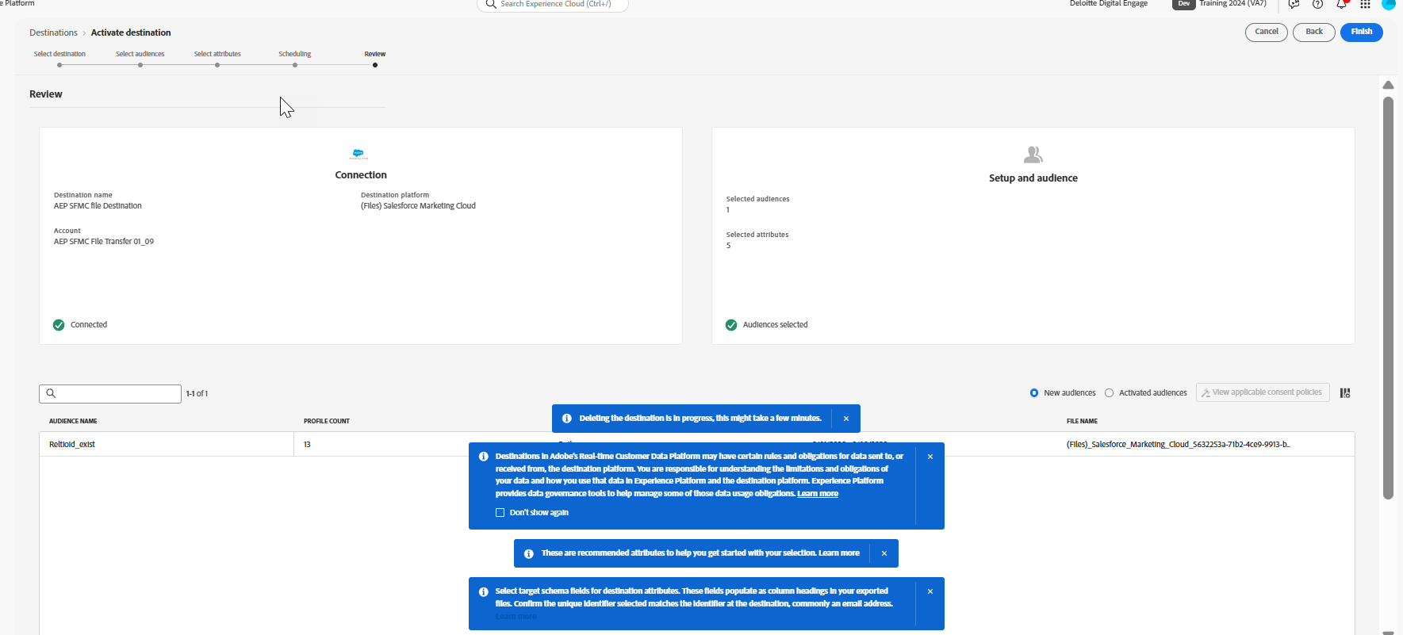

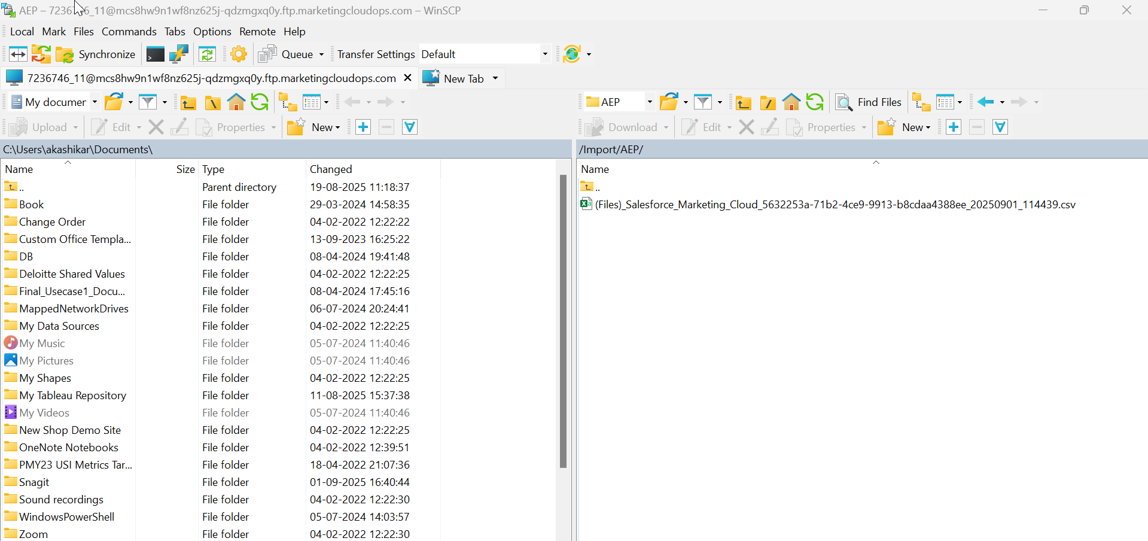

Now once the file reaches SFTP, create an Automation to pull the file from SFTP to a Data Extension which will trigger a SFMC journey.

Create a Data Extension in SFMC that could hold the values of the attributes send from AEP

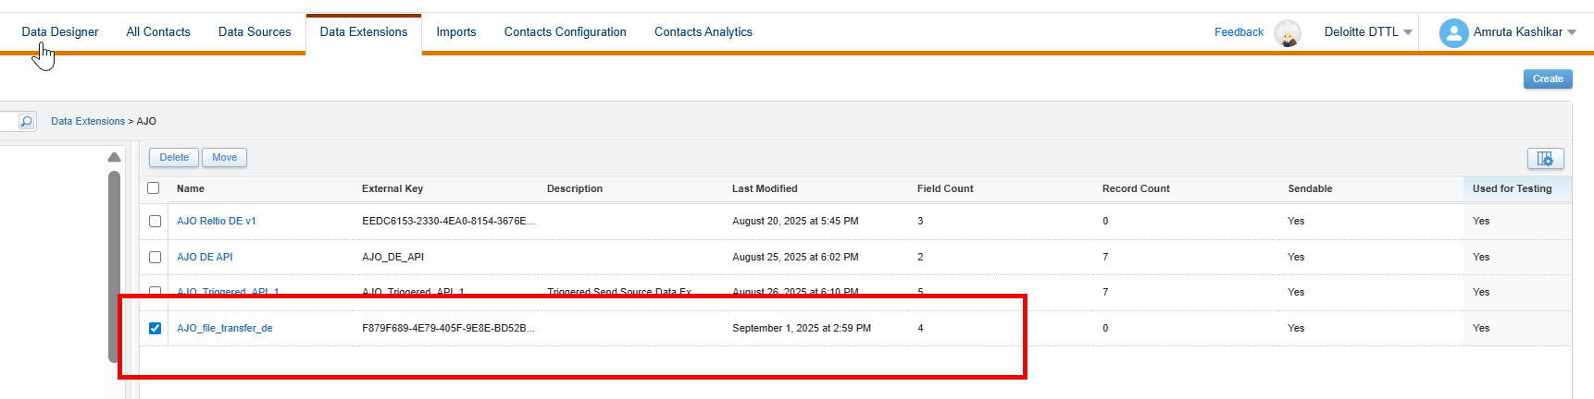

Create a new import job
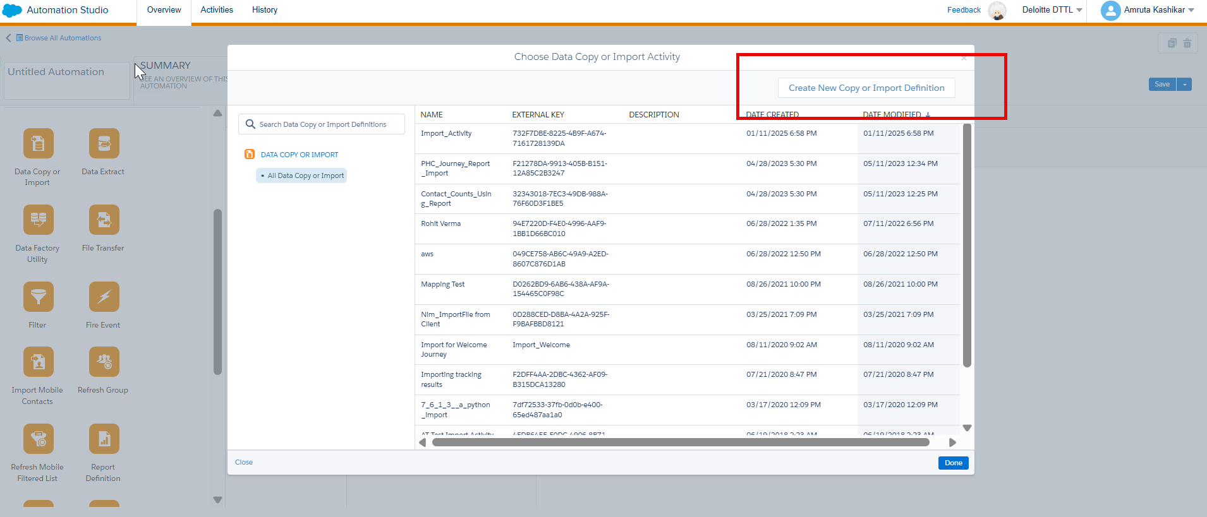

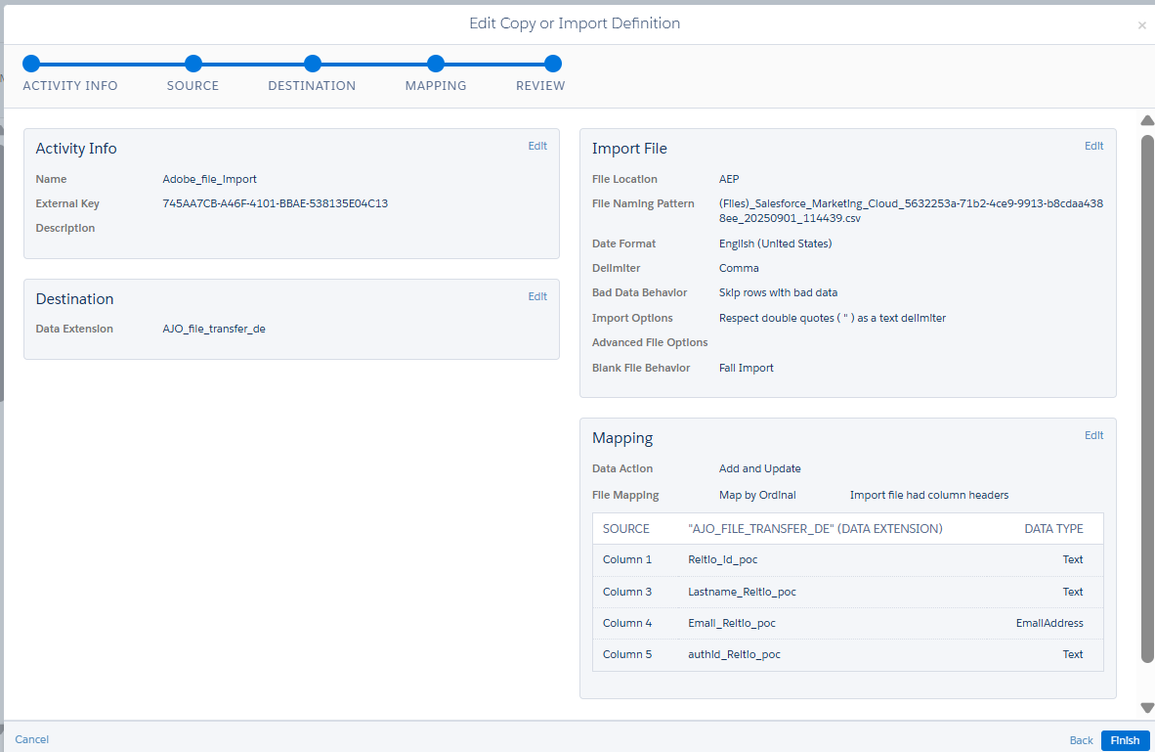

This Automation will Import the File in the SFTP location into the Data Extension

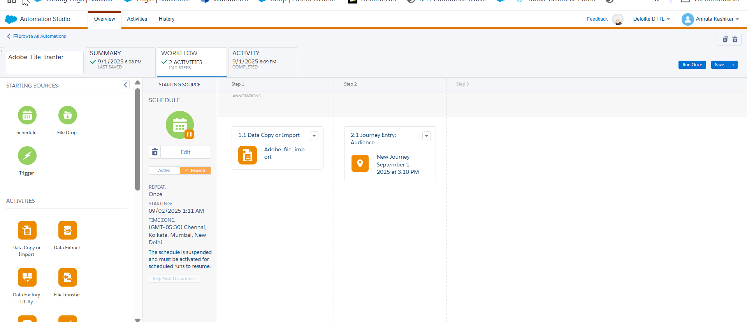

Create a journey – This journey will trigger after the automation is completed

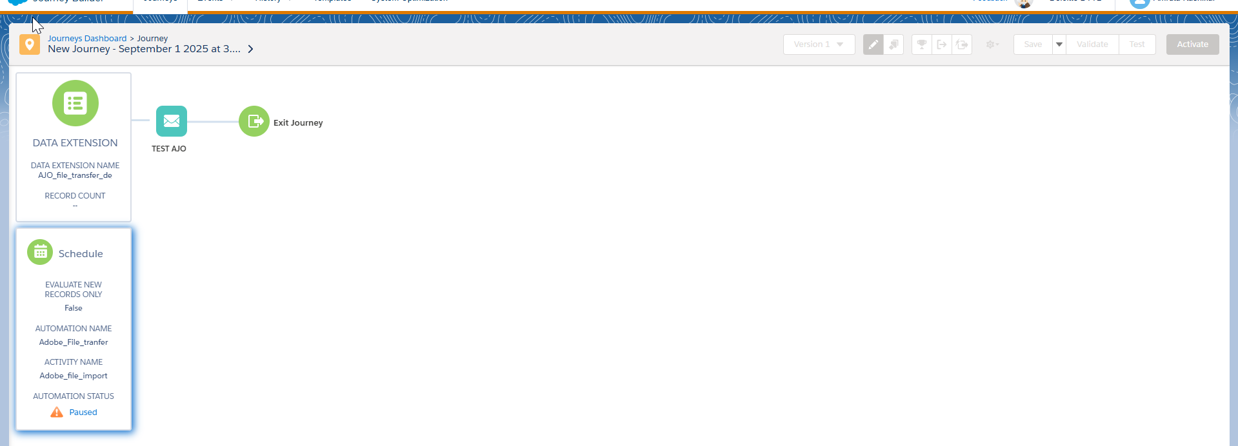

Run the Automation
